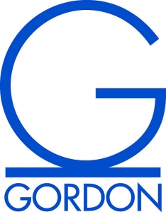
GRASS 2018
Parking Pass
GORDON STATE COLLEGE
Faculty/Staff parking privileges
January 27, 2018
8:00 a.m. – 4:30 p.m.
